**Oregon’s Stunning Scenery and the Geology Driving It**

Oregon boasts some of the most picturesque natural beauty in the continental United States owing to its remarkable geologic history. Oregon’s geology is quite young compared to the rest of the country. The youngest rocks exposed in the state are of Devonian age crated 416-359 million years ago (mya) but these are small outcrops of highly deformed rock found only in in central Oregon. These once formed volcanic islands (like Indonesia) that were tacked onto the North American continent as relatively thin oceanic crust was forced below thicker continental crust in a subduction zone by the process of Plate Tectonics. The complex geologic history of Oregon includes essentially the entire state being rotated 70 degrees clockwise over the past 60 million years.

Oregon has six geologic provinces and three of these (the Coastal Range/Willamette Valley, the Cascade Range, and the Columbia River Plateau) are easily accessible in series of 3-4 hour drives that we have put together. These were designed as day trips with equal time driving through the spectacular scenery and exploring the areas on foot. An excellent guide to have with you when you visit is *the Roadside Geology of Oregon* by Marli B. Miller from which most of this guide was derived and available on Amazon for about $20.

**Background**

The scenic Willamette Valley originated as the “Fore Arc Basin” between these two related tectonic features (similar to the Sundra Arc of Indonesia). As the wet oceanic crust descended below the continent the edge of the continent, it formed the “accretionary wedge” responsible for the Coast Range during the Eocene Epoch (55 – 50 mya). The Coastal Range forms one gigantic fold (anticline) as continued movement on the subsiding plate warps the landscape into a great upwarp with the oldest rocks at the center of the range and younger rocks on the east and west of its core. As the oceanic plate descended deeper into the earth and melted, it formed the molten rock (magma) that rose and continues to erupt today in the Cascade Mountains, a “magmatic arc,” and created Mt. Hood and similarly impressive semi-active volcanoes in Oregon and Washington.

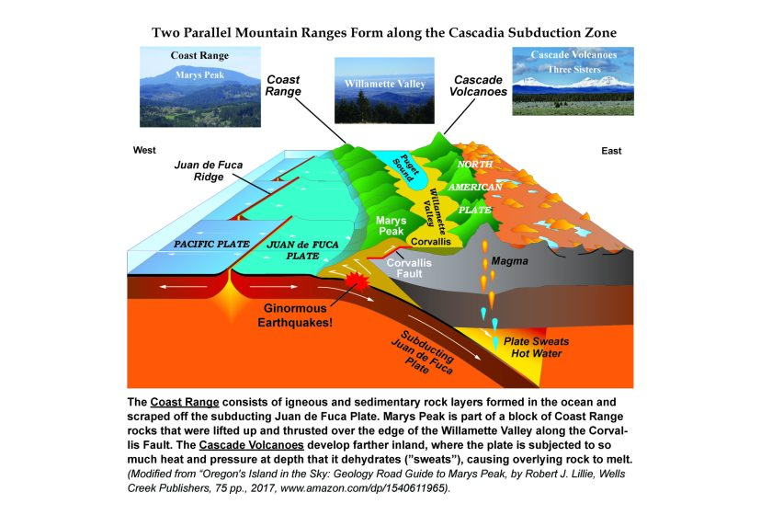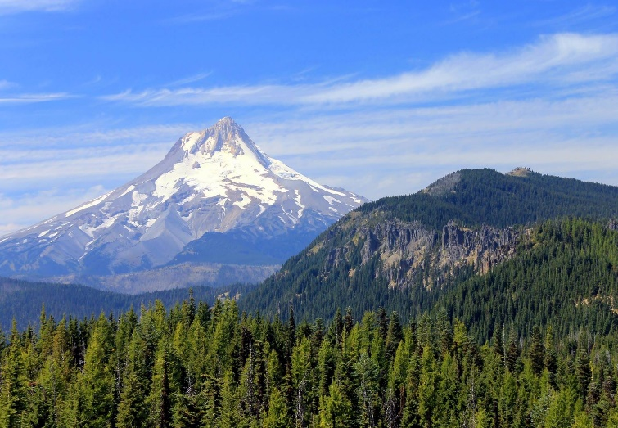

Mt. Hood, Oregon’ Tallest Peak

Northern Oregon’s surface geology is dominated by the Columbia River basalts deposited 16.8 to 6.0 mya. The Columbia River basalts are impressive both on their scale (covering 77,220 square miles from the central Idaho to the Oregon coast) and volume (52,800 cubic miles, enough to fill the Grand Canyon more than fifty times over). These massive basalt sheets originated as a series of multiple flows from the development and migration of the Yellowstone Hot Spot beginning approximately 16 mya and forming the Idaho’s Snake River Canyon. These basalt flows entered the Columbia River Valley and flowed westward to the Pacific Ocean. These flows form majestic cliffs and often exhibit hexagonal column structures that formed while cooling.

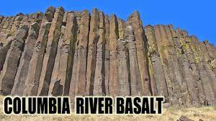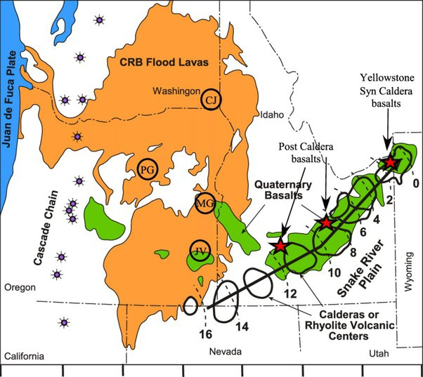

The striking visual scenery of the Columbia River Gorge and Portland area is very, very young (18,000 - 15,000 years ago). The impressive cliffs and numerous spectacular waterfalls were carved by continental-scale glacial flooding that originated in Montana when ice dams formed by continental ice sheets created the enormous Glacial Lake Missoula. These ice dams repeatedly burst, sending flood waters up to 800 feet deep roaring through the Columbia River Valley. These mid-boggling floods occurred for about 2,000 years and repeated about every 50 years. At least 25 of these floods discharged at about 35 million cubic feet per second (cfs) and six at greater than 230 million cfs. These floodwaters tore into the walls of the Columbia River Valley creating the steeply sided gorge of today and easily reached the height of the Crown Point Viewpoint and Vista House east of Portland.

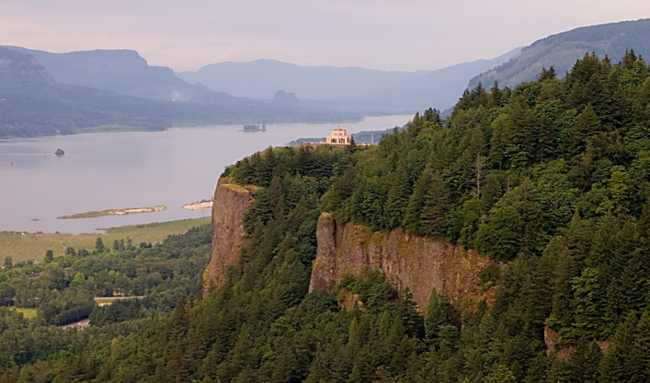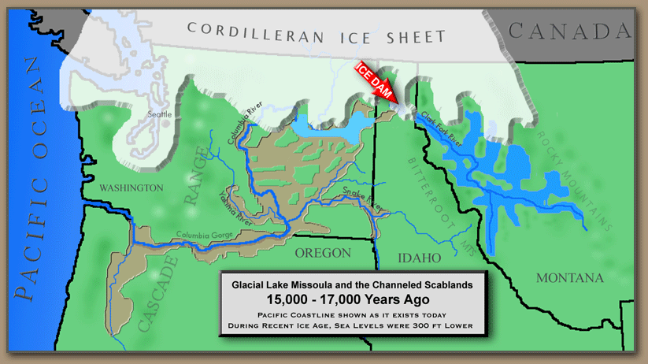

Vista House from Crown Point Viewpoint

The flood waters carried huge icebergs containing boulders called “erratics” from Canada and deposited them 100s of miles from their source. A great place to view one of these geologic oddities is at Erratic Rock State Natural Site, just off Highway 18 southwest of McMinnville, about an hour’s drive southwest of Portland that you may wish to stop by if you are touring the more than 275 wineries of the Willamette Valley.

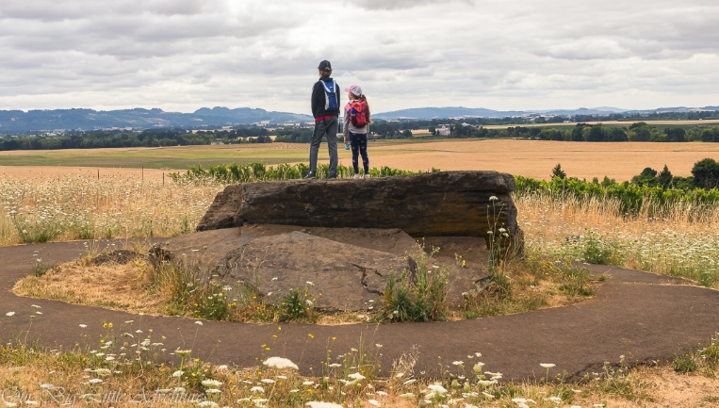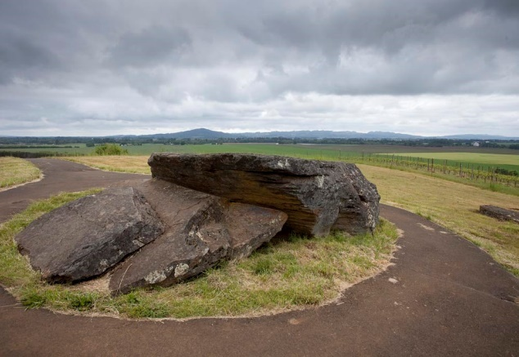

Erratic State Natural Site

Erratic State Natural Site

Some of Oregon’s most dramatic landscapes are found along the Pacific coast where coast erosion cuts into the Coastal Range volcanics and creates sea stacks (also known as haystacks), spits, and pocket beaches that dot the Oregon Coast. One of the most famous , Haystack Rock, is located on US 101, just southwest of Route 26 at Cannon Beach. Further south and just west of Tillamook are the sea stacks and pocket beaches near the scenic Cape Meares Lighthouse and State Scenic Viewpoint. These features owe their picturesque appearance to erosion of the interbedded sedimentary rock (softer) sandwiched between more resistant (harder) volcanic rocks. The surf erodes away the softer rock until the overlying volcanics collapse into the ocean. In many locations the volcanics are at sea level, resulting in tidal pools that are teaming with sea life.

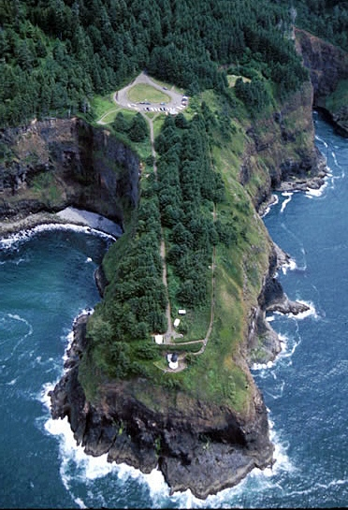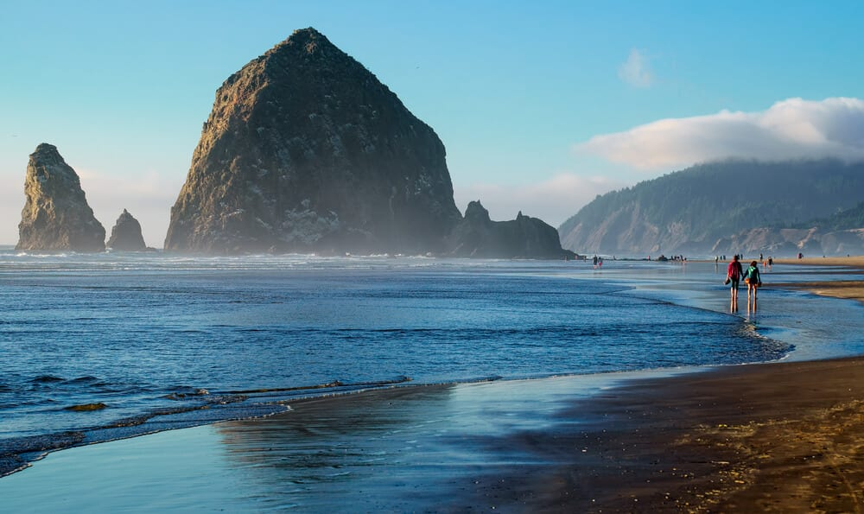

Cape Meares Lighthouse

Haystack Rock

**Drive 1 – Portland to Seaside & Back via Route 30, 101, and 26 (3.75 Hour Drive)**

This drive provides excellent views of the Columbia River Gorge as it cuts through the Coastal Range, stunning views of the Oregon Coast, and fun ride through the Clatsop state forest back to Portland. A slightly longer and more scenic ride, you can take Route 30 which runs along the western side of the gorge, or the faster US I-5 that runs along the east side of the gorge to Longview where you can pick up 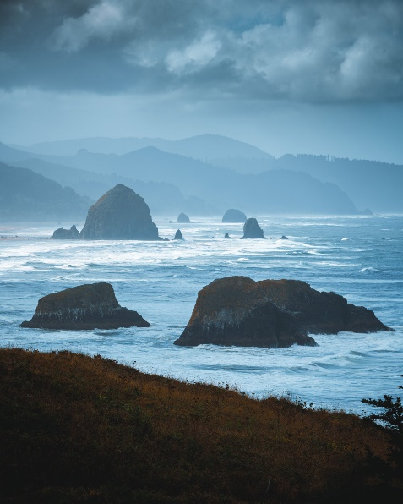Route 30 and head west to the Pacific.

Ecola State Park

The Portland area consists of Miocene (23 to 5 mya) and younger rocks, most notably the Columbia River basalts, Coastal Range volcanics, the Troutdale Formation (sand, gravel and cobble and deposits of the Columbia River), and remnants of the Lake Missoula floods. On the eastern side of Portland near the town of Boring, there are basalt flows and cinder cones that form small buttes, including Rocky Butte, located near the intersection of I-84 and I-205. The rocks near Portland are cut by a complex array of faults, some of which are associated with past strong earthquakes, most notably a 5.0 quake in 1962, and a 5.7 quake that occurred in 1993.

From Portland to Burlington, Route 30 follows the trace of the Portland Hills Fault, and numerous uplifted outcrops of the Columbia River Basalt line the western side of the road. North of Burlington, the road turns eastward away from the fault. Between milepost 37 and the Lewis and Clarke bridge at Rainier are out crops of Older Eocene-aged (56-34 mya) volcanics that are substantially older than the Columbia River Basalts (<16 mya). At Jaquish Road, 0.5 miles south of Goble, are a seemingly random pile of rocks left by construction crews. Some of these are rich in small white and gray zeolite crystals that precipitated in air pockets from circulating ground water after the rock was deposited.   
  
Goble is also the site of Kalama Gap, the narrowest part of the river between Portland and the ocean. Kalama gap served as a hydraulic dam during the Missoula floods, backing water up and flooding the entire Willamette Valley. Past the Lewis and Clark Bridge, Route 30 ascends steeply through the Eocene basalt and into the Columbia river Basalts which cap the ridge top. A particularly good exposure of the Columbia River Basalts is found near milepost 63. A bit farther west, between mileposts 67 and 68, small landslides reveal bedrock of Oligocene and Miocene (34-5 mya) sandstone.

Just west of Westport, Route 30 climbs steeply up Nicolai ridge, a prominent cliff formed of Columbia River Basalts; toward the top of the cliff can be seen the interbedded Astoria Formation, a marine sandstone deposited concurrently with the basalt flows. The Bradley State Scenic Viewpoint sits atop the cliff and offers a beautiful view to the east. Astoria occupies a peninsula formed from the Astoria Formation separating the Columbia and the Young rivers, but very few outcrops exist.

Where Route 30 meets US 101, the coastal area is in full view including the Catslop spit and dunes, as wells as the wreck of the Peter Iredale, a large derelict ship that ran aground in 1906. This northern stretch of US 101 contains numerous basaltic sills intruded into the Astoria sandstone. The Astoria formation contains abundant clam fossils. Just south of Seaside, is Tillamook Head and Ecola State Park where the Astoria formation was folded by the forceful intrusion of the basalt sills related to the Columbia River Basalts. After reaching the cost line in Miocene times, the lava formed broad deltas of pillow basalts that are irregularly bedded, puffed up lava created by rapid cooling of the lava as it hits water. As the basalt deltas grew, their great weight forced the lava downward into the Astoria Formation. Continue south to Cannon Beach and enjoy Haystack Rock before doubling back to take Route 26 home.

Called Oregon’s Sunset Highway, Route 26 passes through deeply forested land. Heading eastward on Route 26 takes you back through the anticlinal, upwarped core of the Coast Range, with the rocks first growing older as you drive east to a few miles past Elise, OR and then becoming younger as you return to the Portland area. For a description of this section of the drive, see the first leg of Drive 2 (below).

**Drive 2 – Portland to Cannon Beach, Tillamook & Return (4.0 Hour Drive)**

This drive largely avoids the Columbia River Gorge to let you spend more time in the Coastal Range mountains and along the Pacific Coast. The outbound leg of this drive is the same as the return leg of Drive 1. Route 26 meets US Highway 101 just north of Cannon Beach Where you can explore that exciting coastal scenery described above (Haystack Rock to Cape Meares).

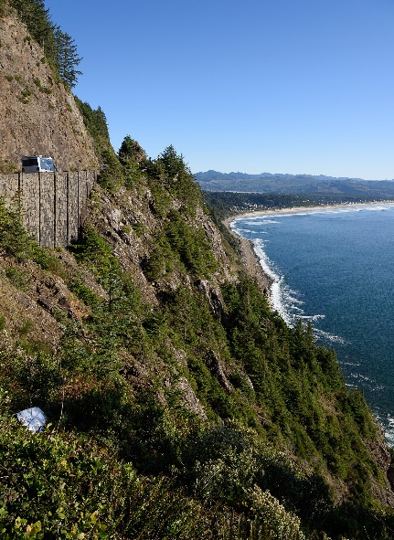

NeahKahnie Mtn Cliffs

Turning west on Route 26 from I-405 in Portland, the Road immediately passes over the Portland hills Fault just before entering the Vista Ridge Tunnel. Some poorly exposed roadcuts of the Columbia River Basalt line the highway just west of the tunnel. A few miles farther west, the older Boring Volcanics (named for Boring, OR), lie on the north side of the highway just east of its intersection with Oregon 217. Good Scappoose Formation sandstone outcrops are exposed between milepost 49 and 50. At milepost 45, you can see good outcrops of deltaic mudstones of the Pittsburg Bluff Formation which contain fossil clams, carbonized wood, and tiny shards of volcanic glass. At milepost 41, you can see the upper part of the tuff-rich mudstones of the Middle-Oligocene (23-34 mya) Keasey Formation. Tuffs are typically volcanic ash deposits that discharged directly from a volcano, rather than settling from the air. Between Mileposts 33 and 32 are good exposures of the Tillamook Volcanics lie on the south side of the road.

After cresting the summit of the Coastal Range, interbedded sandstones and shales of the Eocene (56-34 mya) Cowlitz Formation are exposed between mileposts 23 and 24. There you will note that the dip of the bedding has reversed from the earlier eastward dipping orientation to westward dipping and confirming the anticlinal (upwarp) nature of the Coast Range. Rocks exposed west of the entrance to Saddle Mountain Road and US 101 are almost entirely intrusive sills of the Columbia River Basalt Group and an exceptionally large exposure exists on the north side of the highway between mileposts 6 and 7, behind the Oregon Highway Department Maintenance Station. These show a weak columnar jointing (fracture pattern) which formed during cooling.

From Route 26 at Seaside, turn south on US 101. You will pass Tillamook Point and Haystack Rock (described above). Between mileposts 33 and 34 at the Hug Point State Recreation Area, a Columbia Basalt Group Sill intrudes tilted sandstones of the Astoria Formation. A short walk along the beach reveals numerous alcoves and sea caves have been carved into the rock by the surf as well as more basalt dikes and highly deformed Astoria Sandstone outcrop. Just south of Arch Cape, US 101 enters Oswald West State Park and passes through a tunnel carved into a large basalt intrusion. Between mileposts 39 and 40, a short hike will take you into old growth forests. Near mile marker 41, the Columbia River basalt cliffs of Neahkahnie Mountain line the east side of the road. Near Garabaldi, OR the Tillamook Bay opens up and small sea stacks of south dipping Oligocene-aged marine sedimentary rocks dot the bay. Like most of the northern bays, Tillamook bay is very shallow with an average depth of only 6 feet. During low tide, about half the bay emerges as tidal flats. After a quick visit to Cape Meares and the scenic viewpoint, we turn eastward on Route 6 to return to Portland.

Oregon Route 6 provides a wonderful taste of the Northern Coast Range with its steeply forested valleys carved by meandering rivers. Just east of milepost 4, Route 6 leaves the coastal plain and heads into the Coast Range Mountains. Between Mileposts 9 and 10, the Siletzia Basalt is exposed. This basalt formed during the Paleocene (66-56 mya) when a former island arc developed off the western coast of North America. This basalt is most easily recognized by the characteristic pillow texture, blobs created by the rapid cooling of basalt as it encountered sea water. Near milepost 22-24 , the Wilson River cuts deeply into the Siletzia Basalt with good exposures available to see at the Tillamook Forest center where they are exposed in the river channel. Good exposures of the Tillamook Volcanics are present between mileposts 30 and 31. Overgrown exposures of 30-million year old basaltic intrusive rock can be seen near Milepost 37 before Route 6 joins Route 26 for the ride back to Portland.

**Drive 3 – Portland to the Mt. Hood and Return via Route 26 (3.25 Hour Drive)**

We have intentionally designed this drive as the quickest of the three to allow plenty of time to explore: there are spectacular scenic overlooks and famous water falls along the Columbia River Gorge and phenomenal vistas of the Cascades surrounding the Mt. Hood. It would be easy enough to spend and after an entire afternoon (or day) at any one of several spots along this route. This trip passes on the Coast Range’s scenic coastal exposures to concentrate on the wonders of the Columbia River Gorge and the Cascade Mountains.

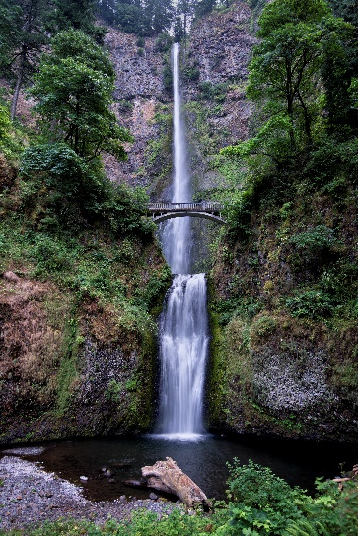

Multnomah Falls

East of downtown Portland, I-84 climbs through an old flood channel created by the Missoula floods that occurred 18,000 to 15,000 years ago. To the north, you can see Rocky Butte; its steep eastern side was eroded by the Missoula floods. To the south is Mt. Tabor. These two buttes are smaller cinder cone volcanoes of the Boring Volcanics (named for Boring, OR) that formed between 97,000 and 203,000 years ago.

At exit 18, you can take the Historic Columbia River Highway toward Oxbow Regional Park. Multiple exposures of the Troutdale Formation, cross-bedded sands and gravels of the ancestral Columbia River dating back 2-15 mya, are present for about 2.5 miles on the east side of the road.

About two miles east of Exit 18, I-84 enters the Columbia River Gorge and hugs the eastern bank of the river. Leaving the interstate at Exit 22 to Corbett, you cover the same distance on the historic highway that parallels I-84 if you want to move at a more leisurely pace. About a mile up the Historic Highway is the Portland Women’s Forum State Scenic Viewpoint which offers a remarkable vista of the Columbia River Gorge. From there, you can look eastward and see Crown Pont and Vista House. During the Missoula Floods, the floodwaters reached the elevation of Crown Point and would have been lapping at the doorstep of Vista House (had it been there). Rooster Rock appears as a spire set out from the cliffs of Crown Point. Both Crown Point and Rooster Rock are formed from the Wanapum Basalt, a member of the Columbia River Basalt Group.

Due to the steep cliffs carved by the Missoula floodwaters, numerous waterfalls, including Latourell Falls, Bridal Veil falls, and Oregon’s tallest, Multnomah Falls, pepper the eastern side of the gorge and are accessible from the Historic Highway. Multnomah Falls, which drops 602 feet is one of Oregon’s most popular tourist attractions and requires a $2 entry fee and a timed entry ticket. You can see the upper half of the falls from I-84 and access the parking area at exit 31. You can reach the bridge at midfalls in a 20 minute walk from the parking area or, if you are in good shape, take 3-4 hours to hike to the top.

At milepost 37, I-84 passes Beacon Rock on the west (Washington State) side of the Columbia river. Beacon Rock is a basaltic plug that was eroded by the Missoula floodwaters. It erupted 50,000 to 60,000 years ago as part of the Boring Volcanics Group. Numerous landslides are apparent on the Washington side of the river at mileposts 34, and one of the largest at mile marker 39. This landslide, which slid between 1450 and 1425 AD, dammed the Columbia River, created a lake that extended more than 50 miles upstream, spawned the Native American “Bridge of the Gods” legend, and pushed the river channel more than a mile to the south. Eventually, the landslide dam broke and sent a 50-foot wall of water downstream into what is now Portland.

The Miocene Eagle Rock Formation, an early debris flow containing petrified trees that was shed from the rising Cascade Mountains, can also be seen at Milepost 37. Good, off-highway exposures of this formation can be found off exit 41 at the Eagle Creek Trail head.

Below Mitchell point at exit 58, the sands and gravels of the Troutdale formation are sandwiched between two Columbia River Basalt group flows. This river deposit rests between the underlying Grande Rhonde Basalt and the overlying Wanapum Basalt. The Columbia River Basalt Group flows are al remarkably similar and the intervening sedimentary rocks are useful to identify individual basalt members. At milepost 60, brown-colored pillow basalts line both sides of the road.

A little farther east at the town of Hood River, we take Exit 64 off the interstate and go south on Route 35 through agricultural land towards Mt. Hood. The deeply dissected hillside to the west on Route 35 is the eastern margin of the Columbia Basalt Plateau geologic province, a high plain uniformly capped by these basalt flows. After 39 miles on Route 35, we turn east towards Government Camp on Route 26 which will take us back to Portland.

Just east of the Government Camp, OR you can turn northward off Route 26 to Mt. Hood via the 5-mile long Timberline Highway. This road climbs 1900 feet past outcrops of andesitic lava and pyroclastic flows to the historic Timberline Lodge where you can look over a fan of pyroclastic flows to the horseshoe -shaped summit crater. Mt Hood is a stratovolcano and, at 11,239 feet, is Oregon’s tallest peak. Most of the volcano formed about 500,000 years ago. Significant eruptions occurred about 1500 years ago, another between 1781 and the mid-1790s, and minor eruptions as recently as 1859 and 1865. Today a number of steam vents are present near the summit, and there are occasional earthquake swarms in the area.

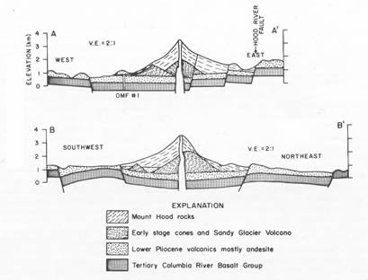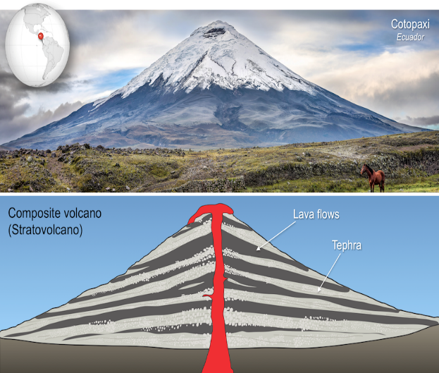

West of Government Camp at milepost 49, Route 26 passes outcrops of 8-9 million year old diorite cliffs that intermittently line the highway for the next two miles to milepost 47. Diorite is an intermediate rock that’s composition, mineral type, and quartz content is halfway between a granite and basalt. East of Brightwood, Route 26 travels over heavily forested pyroclastic (ash flows) and lahars (mud flows) that erupted from Mt. Hood 1500 years ago. From here to Alder Creek near milepost 34, there are almost no outcrops. At the town of Sandy, turn north on Bluff Road and travel about a mile to the Jonsrad Viewpoint which offers a beautiful view of the deeply incised meander bend of the Sandy River and Mt. Hood. Notice the abrupt change in slope near the tree line of Mt. Hood between the steep glacially eroded top of the mountain and the gentler lower reaches made of accumulated pyroclastic flows and lahars. Lahars are volcanic mudflow deposits.

Near Boring, OR (where the Boring Volcanics get their name), there are abundant deposits from lava flows, small shield volcanoes, and cinder cones. These features erupted from some eighty small volcanos between 2.6 million and 50,000 years ago. As we return to Portland, Route 26 crosses gravel deposits of the Missoula floods at the intersection with I-205, but these deposits are hidden by heavy development of the area.